**Department of Educational Technology**

Course code : ICTE 4339

Course Title : Educational Web Design and Development

Assignment no : 01

Assignment on:

5 HTML Question

|  |
| --- |
| **Submitted To** |
| **Mohd. Sultan Ahammad** |
| Assistant Professor |
| Department of Computer Science and Engineering  Mawlana Bhashani Science and Technology University (MBSTU) |
|
|
|
| **Submitted By:**  Ibnul Hossain  ID: 1902008  Educational Technology |
|
|
|
|
|
| **Date of Submission: 9th**  August 2023  **All Output:**  [**https://ihtouhid29.github.io/assignment1/**](https://ihtouhid29.github.io/assignment1/) |  |

1. **Create an external CSS file and link it to an HTML page. Use the CSS file to style the background color, font size, and text color of the page elements.**

**Github Code:**

<https://github.com/ihtouhid29/assignment1/blob/main/1routine.html>

**Output:**

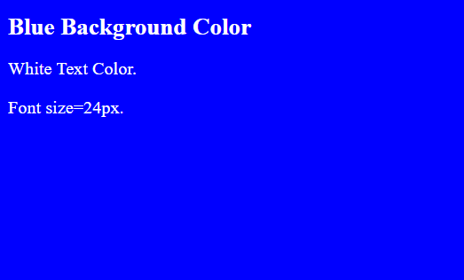

1. **Build a three-column layout using HTML and CSS, where each column contains different types of content (text, images, etc.).**

**Github Code:**

<https://github.com/ihtouhid29/assignment1/blob/main/2business.html>

**Output:**

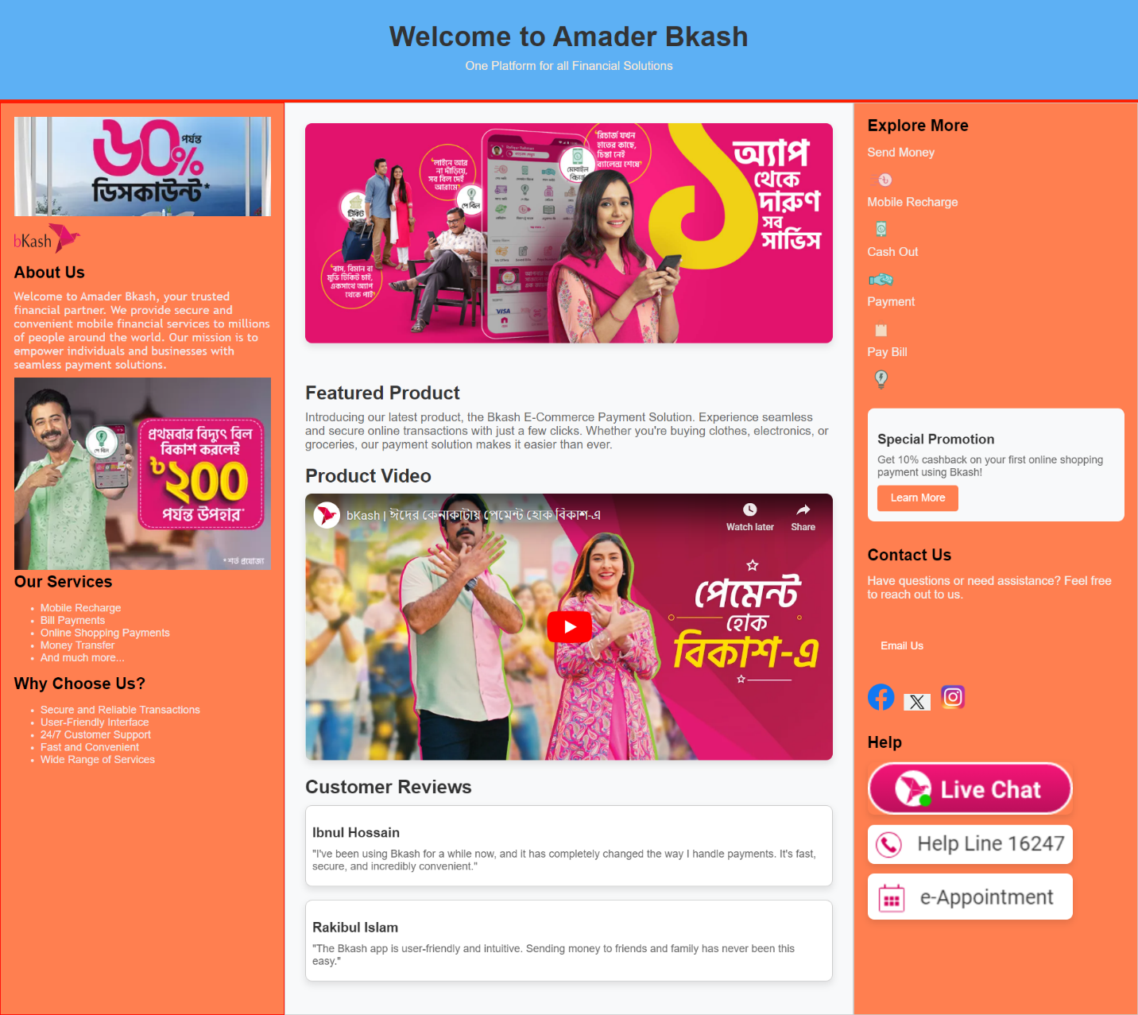

1. **Implement a simple image gallery using HTML and CSS. The gallery should display thumbnails of images and clicking on a thumbnail should display the full-sized image in a lightbox overlay.**

**Github Code:**

<https://github.com/ihtouhid29/assignment1/blob/main/3cap.html>

**Output:**

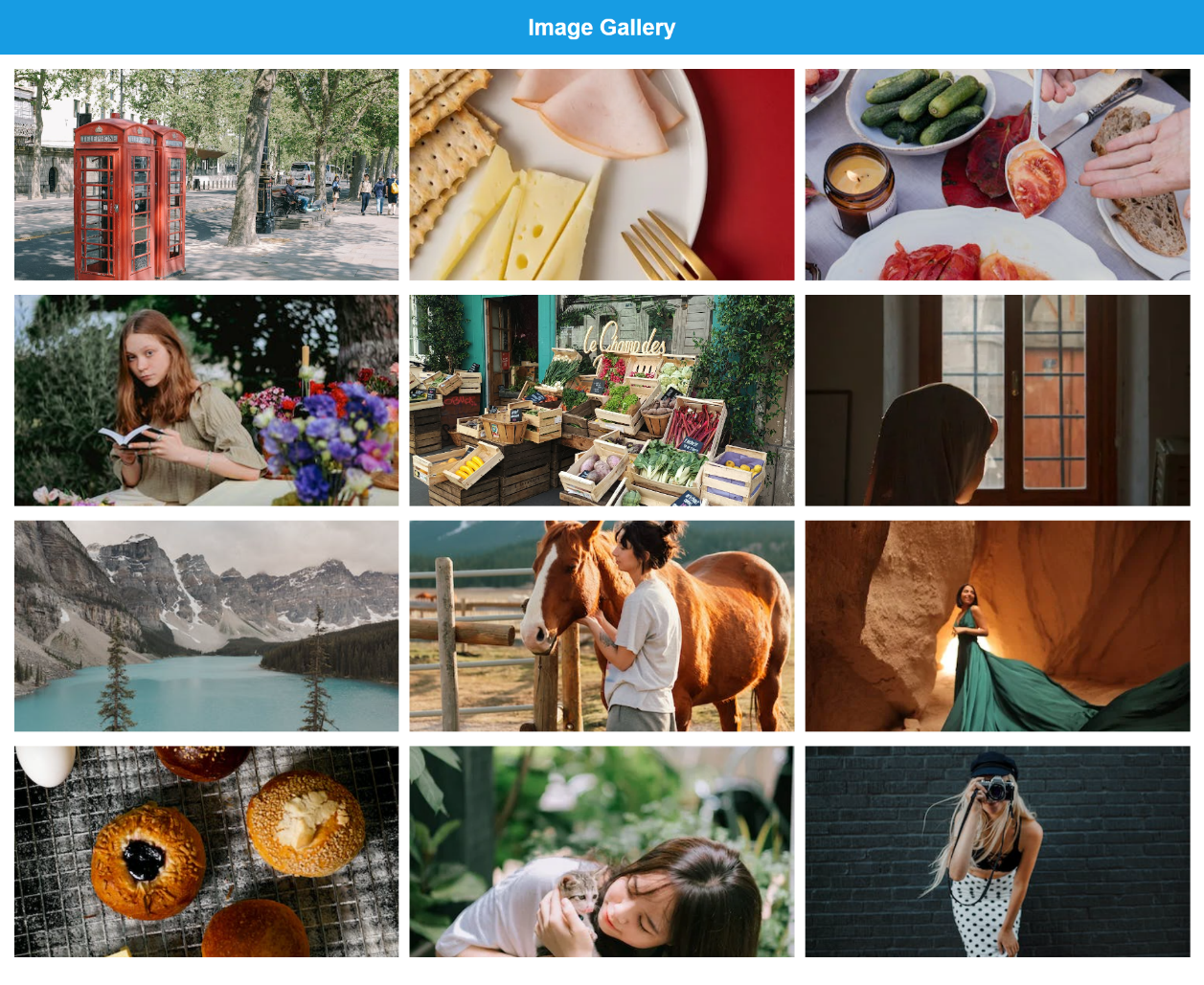

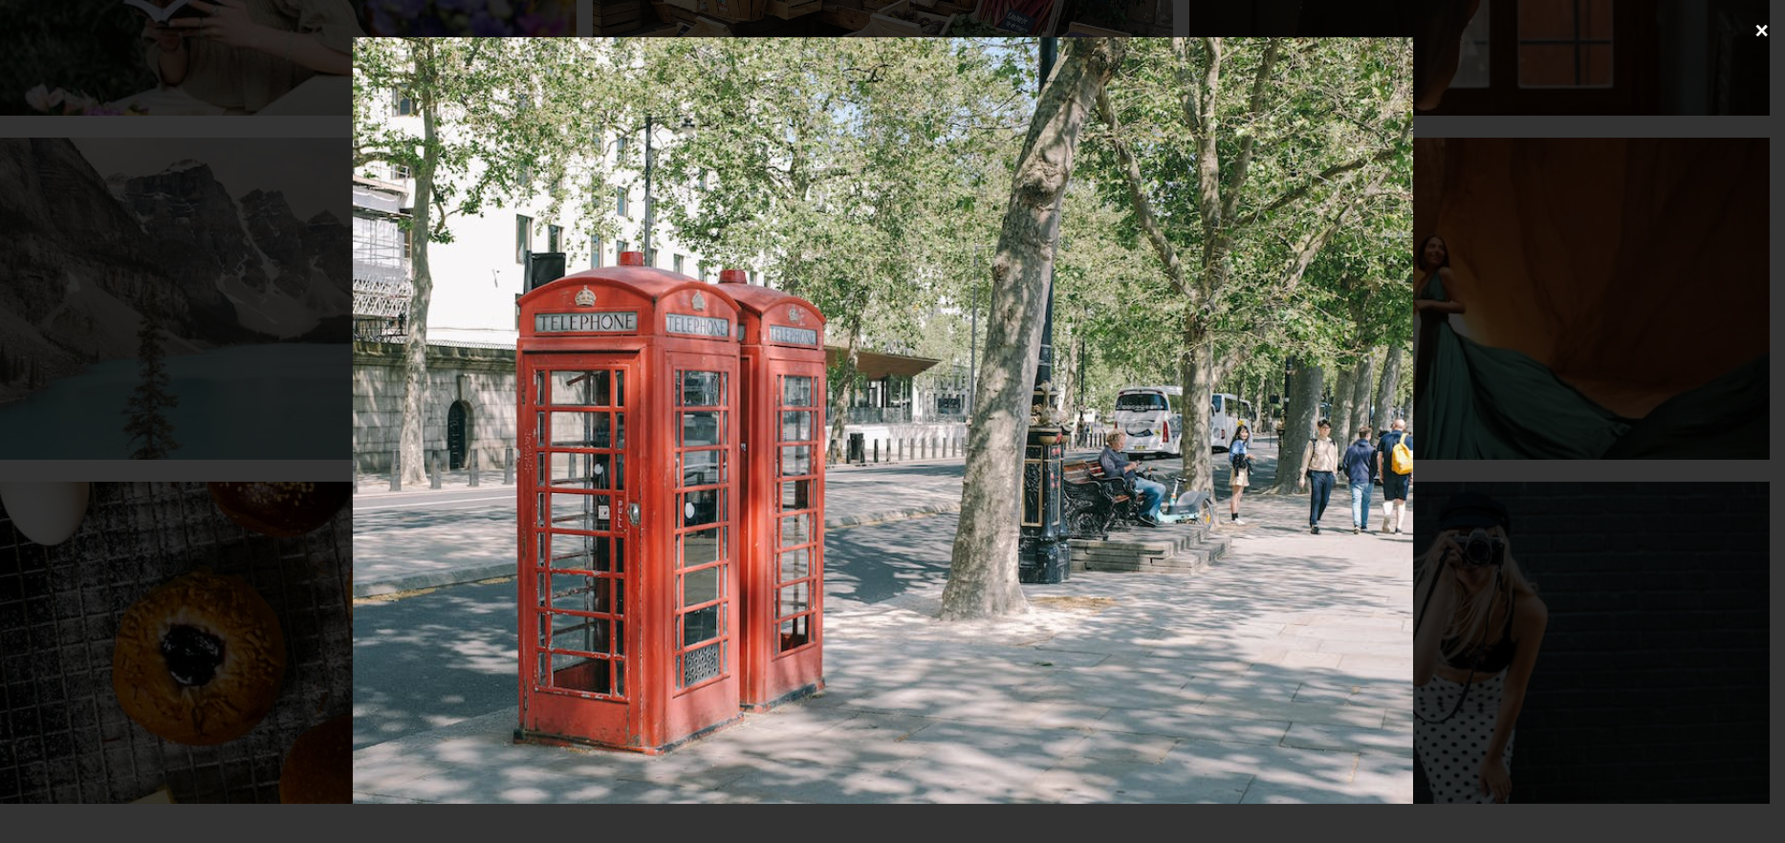

1. **Design a registration form using HTML and CSS and validate the form using HTML5 form validation attributes.**

**Github Code:**

<https://github.com/ihtouhid29/assignment1/blob/main/4personal.html>

**Output:**



1. **Design the following web page using CSS box model.**

**Github Code:**

<https://github.com/ihtouhid29/assignment1/blob/main/5cv.html>

**Output:**

